Your Project
Your Creativity

Our Space
Our Tools

Bettendorf Public Library
Die Cut Catalog

Dies are available for use in the Bettendorf Public Library’s Creation Studio.
More information at www.bettendorflibrary.com/create

DIE NUMBER | DIE DESCRIPTION | CATEGORY | Location | DIMENSIONS
72 | @ symbol | miscellaneous | Youth Services Office | 4"W x 4 1/8"H
56 | 2+ pcs | music | Youth Services Office | Largest note is 3 1/8” W x 3 1/4”H | 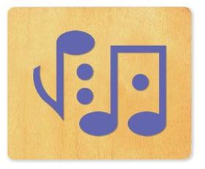
 | Alphabet Set - Block | letters and numbers | Youth Services Office | 4” H | 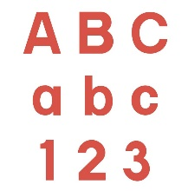
 | Alphabet Set - Vagabond | letters and numbers | Youth Services Office | 2” H | 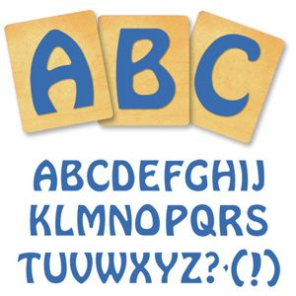
320 | Ankylosaurus | animals | Creation Studio | 5 1/4"W x 1 3/4"H | 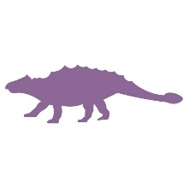
40 | Ants 2 pcs | insect | Youth Services Office | 1 13/16"W x 2 3/16"H | 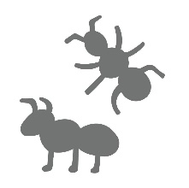
315 | Apatosaurus | animals | Creation Studio | 4 13/16"W x 2 15/16"H | 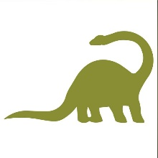
110 | Apple #1 | food | Youth Services Office | 3 3/4"W x 4 5/16"H
117 | Astronaut #1 | space | Youth Services Office | 3 1/2"W x 5"H | 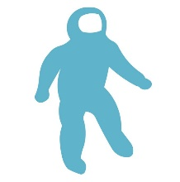
362 | Award #1 | miscellaneous | Creation Studio | 2 15/16"W x 5"H
213 | Bag #2 3D | miscellaneous | Youth Services Office | 2 7/8" x 2" x 6" (Assembled) | 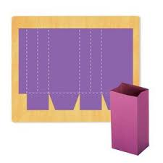
42 | Bag #3 | miscellaneous | Youth Services Office | 4 1/4”W x 5 ¼” H | 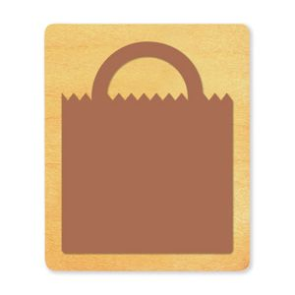
363 | Balloon #1 | miscellaneous | Creation Studio | 3 1/2"W x 5 1/4"H
212 | Balloon #6 | miscellaneous | Youth Services Office | 7"W x 10 3/8"H | 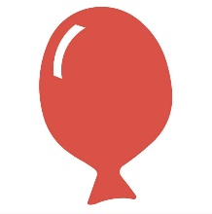
226 | Banana | food | Youth Services Office | 3 7/16"W x 10"H | 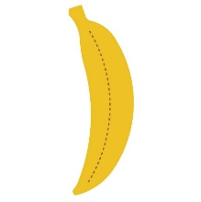
111 | Banana #2 | food | Youth Services Office | 1 11/16"W x 5"H
59 | Banner #1 | miscellaneous | Youth Services Office | 3 3/4"W x 4 11/16"H | 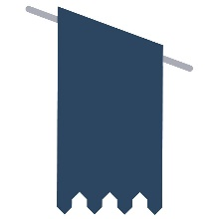
69 | Barn #1 | farm | Youth Services Office | 3 15/16"W x 3 15/16"H | 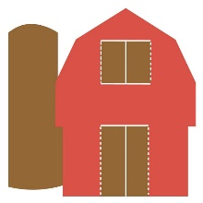
92 | Bayou mini 4 pcs (alligator, turtle, bug, lantern) | miscellaneous | Youth Services Office | Lantern 1 1/8"W x 1 1/5"H, Alligator 1 1/2"W x 1 1/4"H, Turtle 1 1/2"W x 1"H, Firefly 1 1/5"W x 1 1/4"H | 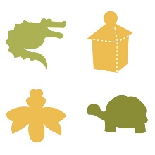
45 | Bird #9 | bird | Youth Services Office | 5"W x 4 1/4"H | 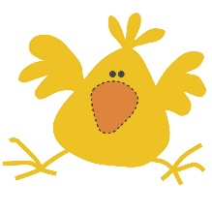
207 | Book - open | books/bookmarks | Youth Services Office | 10 3/16"W x 6 7/16"H
208 | Book - stand | books/bookmarks | Youth Services Office | 13”W x 10 1/2”H | 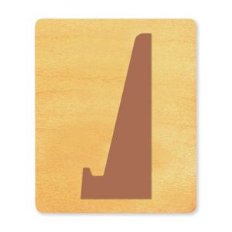
21 | Book closed. 2 pcs | books/bookmarks | Youth Services Office | 2 3/4” W x 5 1/8” H
403 | Book flexagon #1 | books/bookmarks | Creation Studio | 10"W x 7 1/2"H (Flat)
15 | Bookmark - Award | books/bookmarks | Youth Services Office | 1 3/4” W x 5 1/4” H | 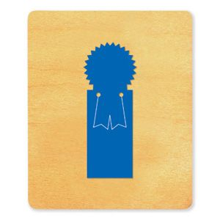
12 | Bookmark - Butterfly | books/bookmarks | Youth Services Office | 4” W x 5 1/2” H | 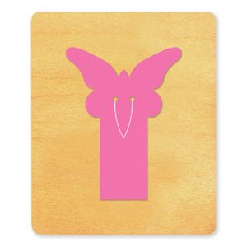
16 | Bookmark - Eagle | books/bookmarks | Youth Services Office | 5 1/8" x 2 1/4"
11 | Bookmark - Frog | books/bookmarks | Youth Services Office | 2 1/2” W x 5” H | 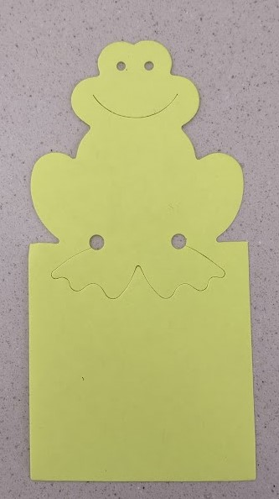
14 | Bookmark - Generic, cut tab at top | books/bookmarks | Youth Services Office | 1 3/4"W x 5 1/8"H | 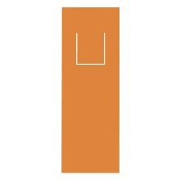
19 | Bookmark - plain, small hole at top for ribbon or string | books/bookmarks | Youth Services Office | 2 5/8”W x 5 1/4”H | 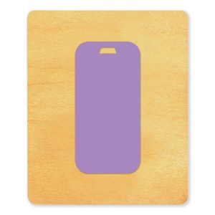
17 | Bookmark - READ | books/bookmarks | Youth Services Office | 1 1/4"W x 5"H
18 | Bookmark - Star | books/bookmarks | Youth Services Office | 5 1/4" x 2 3/8"
13 | Bookmark - Teddy | books/bookmarks | Youth Services Office | 1 3/4” W x 5 1/4”H
22 | Book-Open #2 | books/bookmarks | Youth Services Office | 4 1/8"W x 4 1/4"H
32 | Boxcar | train | Youth Services Office | approx 5 3/8"W x 3 1/16"H
322 | Bulldog mascot | sports | Creation Studio | 4 1/4"W x 4 1/8"H | 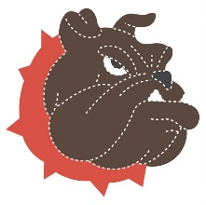
48 | Bulldozer small | construction | Youth Services Office | 2 5/8"W x 1 3/8"H
370 | Butterfly #1 | insect | Creation Studio | 4 13/16"W x 3 3/8"H | 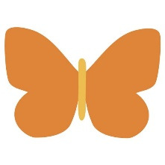
78 | Button | clothing | Youth Services Office | 3” diameter
79 | Buttons #1 mini 4 pcs | clothing | Youth Services Office | 1 1/2" Each | 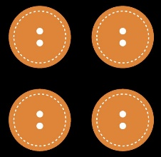
31 | Caboose | train | Youth Services Office | 4 5/8"W x 3 5/8"H
57 | Camera | miscellaneous | Youth Services Office | 5 3/8”W x 3 7/8”H
367 | Camera | miscellaneous | Creation Studio | 4 11/16"W x 2 11/16"H, Circle 1 11/16"
123 | Car #1 | vehicle | Youth Services Office | 5 3/16"W x 1 7/8"H
222 | Card - star | cards/envelopes | Youth Services Office | 3 7/8" x 5 1/4" (Assembled) | 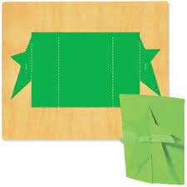
9 | Circle | shape | Youth Services Office | 4 7/16"
300 | Circle | shape | Creation Studio | 4 7/16"
10 | Circle - (clear base for centering) | shape | Youth Services Office | 2 5/8" diameter
215 | Circles 4 pcs | shape | Youth Services Office | 5", 4", 3", 2"
227 | Clothes #1 | clothing | Youth Services Office | Shirt 6 7/16"W x 3 3/4"H, Cap 3 1/4"W x 1 1/4"H, Pants 4"W x 4"H, Shoes 1 13/16"W x 1 3/4"H (ea.) | 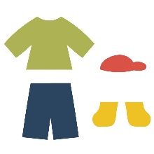
228 | Clothes #2 | clothing | Youth Services Office | Swimsuit 3 1/4"W x 4 3/4"H, Skirt 4 1/16"W x 3"H, Overalls 4 1/16"W x 6 3/4"H | 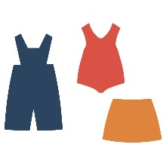
86 | Cow - face | animals | Youth Services Office | 2 1/4"W x 3"H | 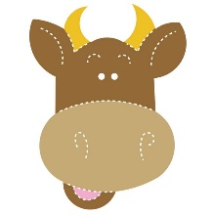
70 | Cow #1 | animals | Youth Services Office | 5 1/8"W x 3 7/8"H | 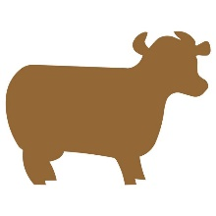
37 | Cowboy boot | clothing | Youth Services Office | 4”W x 5 1/8”H | 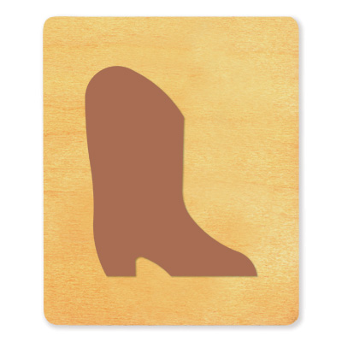
43 | Crayon | miscellaneous | Youth Services Office | 1 1/2"W x 5"H
361 | Crayon | miscellaneous | Creation Studio | 1 1/2"W x 5"H
219 | Crocodile #3 | animals | Youth Services Office | 8 1/8"W x 8 1/8"H | 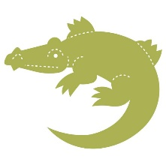
36 | Crown | clothing | Youth Services Office | 5 1/8"W x 3 3/16"H
330 | Cupcake #1 | food | Creation Studio | 4 7/16"W x 3 11/16"H | 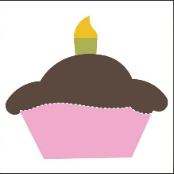
76 | Dinosaur #1 - Stegosaurus | animals | Youth Services Office | 4 13/16"W x 2 7/16"H | 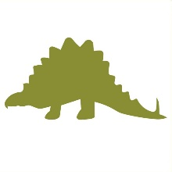
314 | Dinosaur #1 - Stegosaurus | animals | Creation Studio | 4 13/16"W x 2 7/16"H
310 | Dog - Bulldog | animals | Creation Studio | 3 3/4"W x 3 15/16"H | 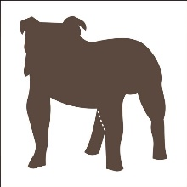
87 | Dog #1 | animals | Youth Services Office | 4 15/16"W x 4 3/16"H | 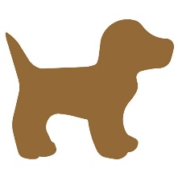
332 | Dolphin Mascot | underwater | Creation Studio | 4 1/4"W x 5 3/8"H | 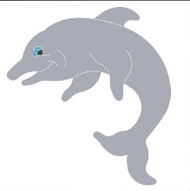
96 | Dragon #1 | miscellaneous | Youth Services Office | 4 9/16"W x 4 1/8"H
106 | Duck | bird | Youth Services Office | 4”W x 4 1/2”H | 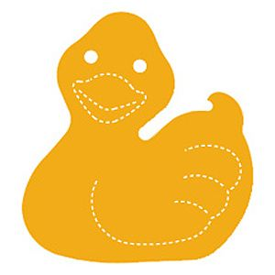
47 | Dump Truck small | construction | Youth Services Office | 2 5/8"W x 1 1/4"H
67 | Elephant #1 | animals | Youth Services Office | 5"W x 3 5/8"H
202 | Envelope #2 | cards/envelopes | Youth Services Office | 6 1/2”W x 3 3/4” H | 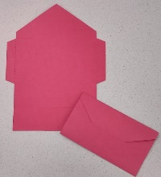
203 | Envelope #4 | cards/envelopes | Youth Services Office | 5" x 6 1/2" | 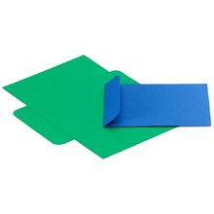
229 | Envelope #5 Crease | cards/envelopes | Youth Services Office | 5"W x 3 13/16"H (Folded) | 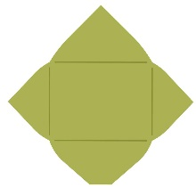
58 | Feather | bird | Youth Services Office | 1 9/16"W x 5 5/16"H
27 | Fingerpuppet - Frog | puppet | Youth Services Office | 3 12” W x 4 1/4” H | 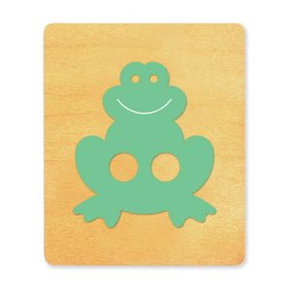
26 | Fingerpuppet - Teddy Bear | puppet | Youth Services Office | 4 3/16"W x 4 9/16"H | 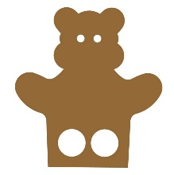
61 | Firetruck | miscellaneous | Youth Services Office | 3 7/8"W x 2 1/4" H | 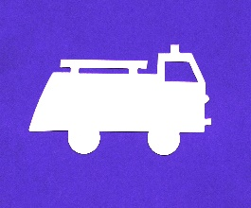
65 | Fish #4 | underwater | Youth Services Office | 5"W x 1 13/16"H | 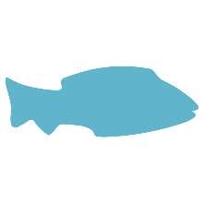
81 | Fishbowl | underwater | Youth Services Office | 4 1/2"W x 4"H | 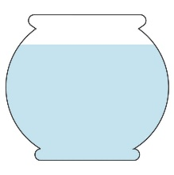
54 | Flag #3 | miscellaneous | Youth Services Office | 5"W x 4 1/8"H | 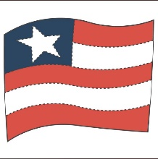
354 | Flag #3 | miscellaneous | Creation Studio | 5"W x 4 1/8"H
108 | Flask | miscellaneous | Youth Services Office | 3 11/16"W x 5 1/16"H | 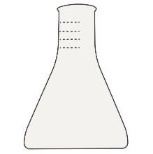
358 | Fleur-de-lis #3 | miscellaneous | Creation Studio | 4 3/8"W x 4 3/4"H
356 | Flexagon "long cut" 2 pcs | miscellaneous | Creation Studio | 11 1/8"W x 1 3/4"H | 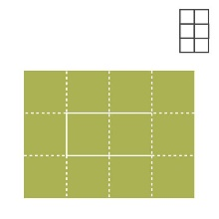
206 | Flip-flaps | miscellaneous | Youth Services Office | 11 1/2"W x 6 3/4"H | 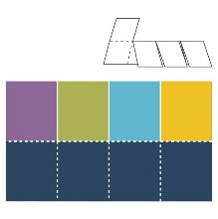
2 | Flower - Nested 2 pcs | plants | Youth Services Office | 4 3/8", Inside 2 3/16"
341 | Flower - Tulip | plants | Creation Studio | 2 5/8"W x 4 15/16"H
340 | Flower #12 | plants | Creation Studio | 4 1/2"W x 3 9/16"H
339 | Flower #14 | plants | Creation Studio | 4 1/4"W x 4 1/4"H
400 | Foam finger | sports | Creation Studio | 6"W x 10"H | 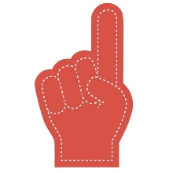
404 | Fold-up #1 (rectangle opening) | cards/envelopes | Creation Studio | 3 11/16"W x 4 3/8"H (Folded), Inside 2"W x 3"H
405 | Fold-up #2 (oval opening, 7.5" x 8.75") | cards/envelopes | Creation Studio | 3 11/16"W x 4 3/8"H (Folded), Inside 2"W x 3"H
338 | Fold-up flower #1 | plants | Creation Studio | Flat: 4 3/5"W x 1 1/8"H | 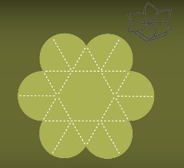
204 | Footprint #2 | miscellaneous | Youth Services Office | 4 3/8” W x 12 1/8” H | 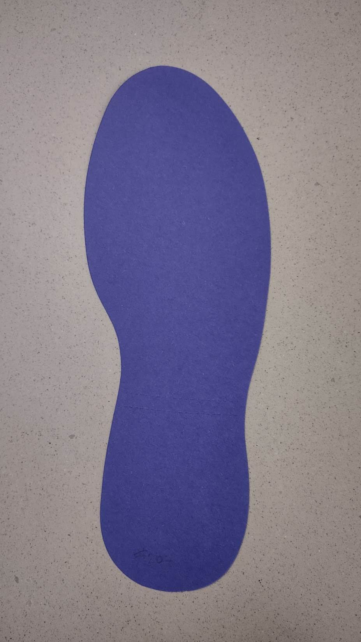
342 | Four-leaf clover #1 | plants | Creation Studio | 4"W x 4 3/16"H
312 | Frog #1 | animals | Creation Studio | 4"W x 4 9/16"H | 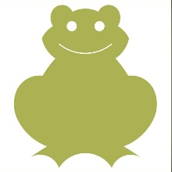
313 | Frog #2 | animals | Creation Studio | 4 3/8"W x 3 5/8"H | 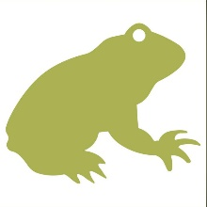
224 | Gears #2 3 pcs | miscellaneous | Youth Services Office | 2 3/8", 3 1/2", 4 1/2"
97 | Gecko | animals | Youth Services Office | 5 1/8"W x 2 7/8"H | 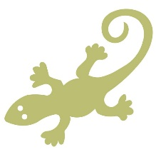
89 | Gift tag #3 | cards/envelopes | Youth Services Office | 2 9/16"W x 5"H
329 | Gingerbread man #1 | food | Creation Studio | 3 3/8"W x 4 3/4"H | 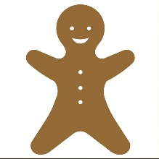
66 | Giraffe | animals | Youth Services Office | 2 1/2"W x 4 3/4"H | 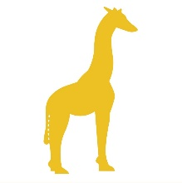
51 | Grader small | construction | Youth Services Office | 5 7/8”W x 1 1/4”H | 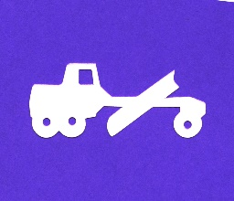
120 | Guitar - electric | music | Youth Services Office | 1 3/4"W x 5"H
49 | Hammer | tool | Youth Services Office | 3"W x 4 7/8" | 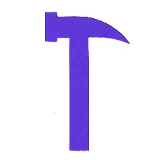
357 | Hand #1 | miscellaneous | Creation Studio | 3 15/16"W x 5 3/16"H | 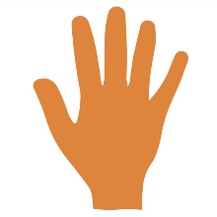
24 | Hand-Closed | miscellaneous | Youth Services Office | 3 1/16"W x 4 3/4"H | 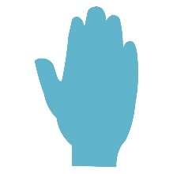
25 | Handprint #2 Open | miscellaneous | Youth Services Office | 4 1/2"W x 4"H | 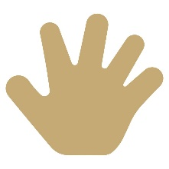
353 | Happy face #1 | miscellaneous | Creation Studio | 4 5/16"
348 | Hat Striped | clothing | Creation Studio | 4 1/16"W x 5"H | 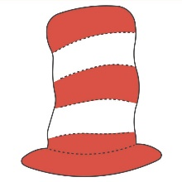
402 | Hat Striped (cat in the hat style) | clothing | Creation Studio | 8 3/16"W x 10"H
5 | Heart #2 | shape | Youth Services Office | 2.75"
122 | Heart #2 | shape | Youth Services Office | 5 1/8"W x 4 1/8"H
115 | Heart #6 | shape | Youth Services Office | 4 3/8"W x 4 5/16"H
109 | Horse #1 | animals | Youth Services Office | 5"W x 4 3/16"H | 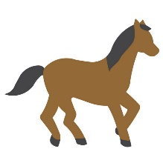
44 | Ice cream and cone 2 pcs | food | Youth Services Office | 3 9/16"W x 5 3/4"H
328 | Ice cream and cone 2 pcs | food | Creation Studio | 3 9/16"W x 5 3/4"H
324 | Ice Skate | sports | Creation Studio | 4 7/8"W x 4 1/8"H | 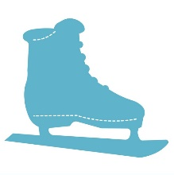
3 | Insects - mini 4 pcs | insect | Youth Services Office | Ladybug 1 1/4"W x 1 1/2"H, Ant 1 3/8"W x 1 1/2"H, Fly 1 1/2"W x 1 9/16"H, Beetle 1 5/8"W x 1 1/4"H | 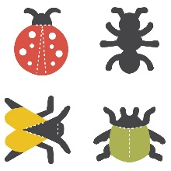
62 | Iowa - state shape | miscellaneous | Youth Services Office | 5”W x 3 1/8”H | 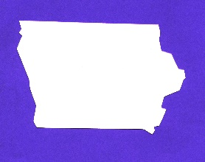
80 | Itty-bitty fish 4 pcs | underwater | Youth Services Office | 1”W x 1/2”H each | 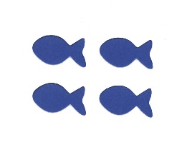
311 | Kangaroo | animals | Creation Studio | 3 7/8"W x 4 3/8"H | 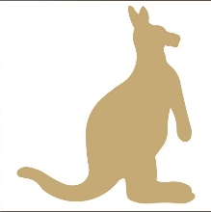
99 | Key | miscellaneous | Youth Services Office | 2 3/4"W x 5"H
352 | Key | miscellaneous | Creation Studio | 2 3/4"W x 5"H
100 | Key small | miscellaneous | Youth Services Office | 1 5/8"W x 3"H
336 | Leaf - Maple | plants | Creation Studio | 4 3/8"W x 4 3/8"H
28 | Leaf - Oak | plants | Youth Services Office | 3 1/2”W x 5 1/2”H | 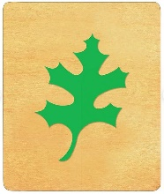
91 | Leaf - pond | plants | Youth Services Office | 3 3/4"W x 5 13/16"H | 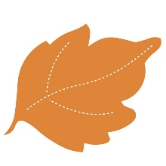
337 | Leaf #1 | plants | Creation Studio | 3 15/16"W x 4 5/16"H
29 | Leaves - Jungle 2 pcs | plants | Youth Services Office | 2 7/8"W x 4"H | 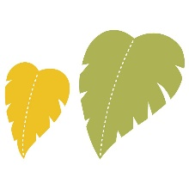
401 | Leaves #4 4 pcs | plants | Creation Studio | 5"W x 5"H; 2 1/2"W x 5"H  ; 3 3/8"W x 4"H; 4 5/8"W x 4 3/4"H | 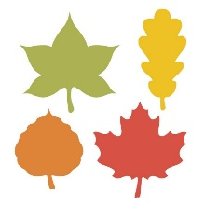
211 | Lightbulb #1 | miscellaneous | Youth Services Office | 5 11/16"W x 10 1/8"H
68 | Lion #1 | animals | Youth Services Office | 5 1/8"W x 3 7/8"H | 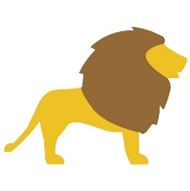
33 | Locomotive #1 | train | Youth Services Office | 5"W x 3 1/16"H
128 | Log Cabin #1 | miscellaneous | YS | 4 3/4"W x 3 1/2"H
75 | LONG Door hanger | miscellaneous | Youth Services Office | 4 1/16"W x 10 1/4"H
74 | LONG Glasses frame | clothing | Youth Services Office | Frame 5 1/16"W x 2 3/16"H, Stem 4"W x 1"H (ea.)
130 | LONG Hat band | clothing | YS | 2" W x 14" L
73 | LONG Notecard envelope | cards/envelopes | Youth Services Office | 3 5/8” x 10 1/2”H
129 | LONG Reindeer (3D) 4 pcs | animals | YS | 15" W x 4 1/4"H | 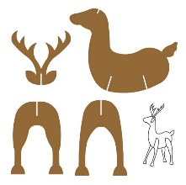
94 | Luggage | miscellaneous | Youth Services Office | 4 11/16"W x 3"H
53 | Magnifying glass | tool | Youth Services Office | 2 11/16"W x 5 1/8"H
407 | Mask - Cat | mask | Creation Studio | 8 7/8"W x 7 7/8"H
406 | Mask - Dog | mask | Creation Studio | 9 9/16"W x 7 13/16"H | 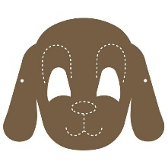
350 | Mask #2 "long cut" | mask | Creation Studio | 7 1/16"W x 2 1/2"H
408 | Mask #3 (5.25" x 6.5") | mask | Creation Studio | 6 1/2"W x 5 3/16"H
131 | Megaphone #1 | sports | Youth Services Office | 2 1/2"W x 4 3/4"L
347 | Mitten #2 | clothing | Creation Studio | 3 5/16"W x 5 5/16"H | 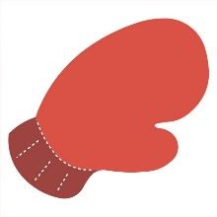
112 | Monkey #1 | animals | Youth Services Office | 3 13/16"W x 4 7/16"H | 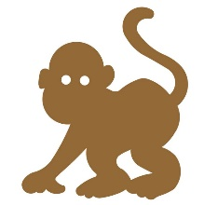
38 | Monkey #2 | animals | Youth Services Office | 4"W x 5 1/4"H | 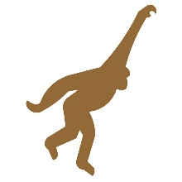
104 | Mouse | animals | Youth Services Office | 2 1/4"W x 3"H | 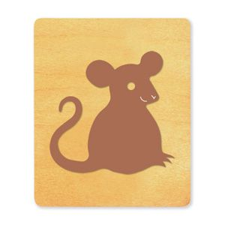
114 | Music note #1 large | music | Youth Services Office | 2 7/8"W x 5"H
102 | Music Note #2 small | music | Youth Services Office | 2 5/8"W x 3 3/16"H
214 | Music notes 2+ pcs | music | Youth Services Office | Largest note: 6 14”W x 6 1/2” H
84 | Octopus #2 | underwater | Youth Services Office | 4 7/8"W x 4"H
4 | Oval | shape | Youth Services Office | 3"W x 4"H
301 | Oval | shape | Creation Studio | 3"W x 4"H
105 | Pail and shovel 2 pcs | tool | Youth Services Office | Shovel 1"W x 3 7/8"H, Pail 3 3/8"W x 3 3/4"H
343 | Palm tree | plants | Creation Studio | 4 1/4"W x 4 1/2"H
302 | Parallelogram | shape | Creation Studio | 4"W x 3 5/8"H (Sides 4 3/16")
39 | Pawprint Mascot 3 | animals | Youth Services Office | 4 1/2"W x 4 3/16"H | 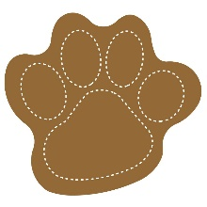
85 | Pelican #1 | bird | Youth Services Office | 4 3/16"W x 5"H | 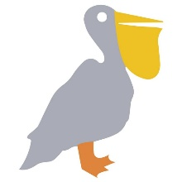
125 | Pickup truck | vehicle | Youth Services Office | 5"W x 1 5/8"H
64 | Pig | animals | Youth Services Office | 5 1/8"W x 2 3/4"H | 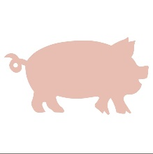
118 | Planets (1 of 2) 6 pcs | space | Youth Services Office | 5"W x 3"H, 3 1/2", 1 3/8" (ea.), 13/16", 3/4", 7/16", 5/16", 3/16"
119 | Planets (2 of 2) 3 pcs | space | Youth Services Office | 5"W x 3"H, 3 1/2", 1 3/8" (ea.), 13/16", 3/4", 7/16", 5/16", 3/16"
50 | Pliers and Screwdriver 2 pcs | tool | Youth Services Office | pliers: 2 1/4"W x 3 5/8"H screwdriver: 9/16"W x 4 1/2"H | 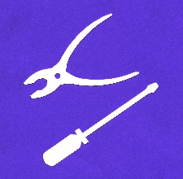
201 | Pop-Up Multiple Card | cards/envelopes | Youth Services Office | 6" x 4 1/4" | 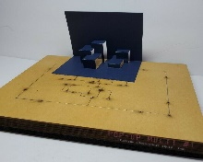
52 | Power shovel small | construction | Youth Services Office | 2 1/2”W x 1 3/4”H | 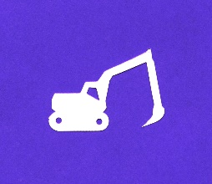
216 | Practice wheel (1 of 2) | miscellaneous | Youth Services Office | 6"W x 8 7/8"H (Assembled) | 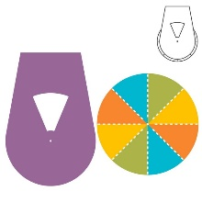
217 | Practice wheel (2 of 2) | miscellaneous | Youth Services Office | 6"W x 8 7/8"H (Assembled)
319 | Protoceratops | animals | Creation Studio | 5 1/4"W x 2 5/16"H | 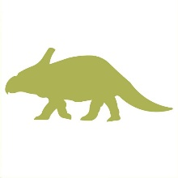
317 | Pterodactyl | animals | Creation Studio | 5 15/16"W x 3 11/16"H
335 | Pumpkin #2 (Jack-o-lantern) | miscellaneous | Creation Studio | 4 1/16"W x 3"H | 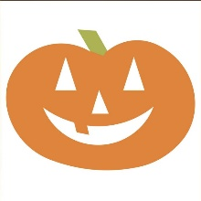
334 | Pumpkin #4 | plants | Creation Studio | 4 3/4"W x 4 5/16"H | 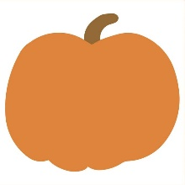
23 | Pumpkin #7 | plants | Youth Services Office | Pumpkin 4 11/16"W x 4 7/16"H, Leaf 2"W x 1 1/16"H | 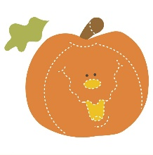
223 | Puppet body | puppet | Youth Services Office | 8 5/16"W x 10 7/16"H
210 | Puzzle #3 15 pcs | miscellaneous | Youth Services Office | 9 1/4"W x 7 3/4"H
209 | Puzzle #9 3 pcs | miscellaneous | Youth Services Office | 11 3/4"W x 5"H
103 | Rabbit bunny #2 | animals | Youth Services Office | 3 3/4"W x 5 1/8"H | 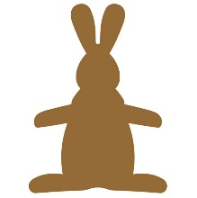
309 | Rat | animals | Creation Studio | 4 3/8"W x 5 3/8"H | 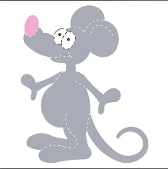
225 | Record (45 rpm!!) | music | Youth Services Office | 6"
303 | Rectangle | shape | Creation Studio | 4 5/8"W x 2 7/8"H
8 | Rectangle (clear base for centering) | shape | Youth Services Office | 3.75" x 1.75"
107 | Recycling symbol 4 pcs | miscellaneous | Youth Services Office | 3"
365 | Sailboat #2 | miscellaneous | Creation Studio | 4 7/8"W x 4 3/16"H
46 | Saw | tool | Youth Services Office | 5 1/8”W x 2 1/4”H
63 | Scarecrow | farm | Youth Services Office | 3 1/2"W x 5"H
359 | Schoolhouse #1 | miscellaneous | Creation Studio | 3 7/8"W x 5"H | 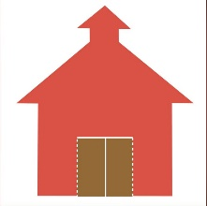
360 | Schoolhouse #3 | miscellaneous | Creation Studio | 4 1/4"W x 4 9/16"H
77 | Shamrock #1 | miscellaneous | Youth Services Office | 4 1/2"W x 3 13/16"H
366 | Shamrock #1 | miscellaneous | Creation Studio | 4 1/2"W x 3 13/16"H
333 | Shark | underwater | Creation Studio | 5"W x 2 5/8"H | 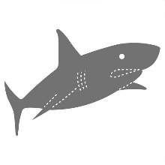
93 | Shell #1 | underwater | Youth Services Office | 4 5/16"W x 4 3/16"H
55 | Shield | miscellaneous | Youth Services Office | 5"W x 4 3/16"H
346 | Shoe #2 | clothing | Creation Studio | 4 15/16"W x 2 7/16"H | 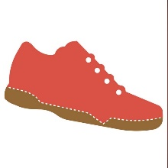
98 | Shovel #2 | tool | Youth Services Office | 1 1/4"W x 5"H | 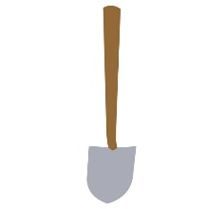
30 | Snowflake #1 | winter | Youth Services Office | 4 1/4” diameter
327 | Snowflake #1 | winter | Creation Studio | 4 1/16"W x 4 1/16"H
326 | Snowflake #5 | winter | Creation Studio | 4 3/4"H
88 | Snowman #4 | winter | Youth Services Office | 3 1/8"W x 5 1/16"H | 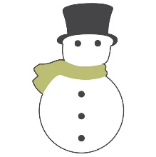
221 | Snowman 3D 2 pcs | winter | Youth Services Office | 6 1/2” W x 8 1/2” H | 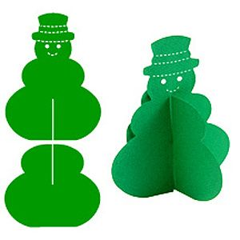
325 | Snowman picture frame 4 pcs "long cut" (snowman 4.5" x 3", hat 1.25" x 2", picture opening 1.75" diameter) | winter | Creation Studio | 3"W x 4 1/2" (Assembled) | 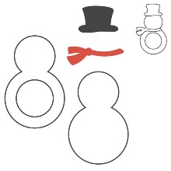
116 | Space shuttle #1 | space | Youth Services Office | 3 1/4"W x 5 1/4"H
323 | Spartan (Trojan) mascot | sports | Creation Studio | 3 13/16"W x 4 5/8"H | 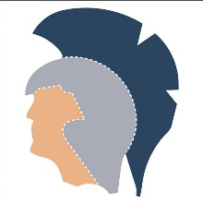
60 | Sports Fever mini 4 pcs | sports | Youth Services Office | Megaphone 1 1/2"W x 1 1/4"H, Football 1 1/2"W x 7/8"H, Pennant 1 1/2"W x 15/16"H, Hand #1 15/16"W x 1 1/2"H | 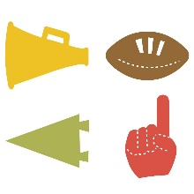
6 | Square | shape | Youth Services Office | 4" x 4"
304 | Square | shape | Creation Studio | 4" x 4"
307 | Star #1 | shape | Creation Studio | 4"W x 3 13/16"H
1 | Star #3 | shape | Youth Services Office | 4 1/8"W x 3 15/16"H
308 | Star #3 | shape | Creation Studio | 4 1/8"W x 3 15/16"H
83 | Starfish | underwater | Youth Services Office | 4 5/8"W x 4 3/8"H | 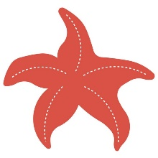
124 | Stock car | vehicle | Youth Services Office | 5 1/8"W x 2"H
 | Strawbees #1 |  | Youth Services Office | 1 Prong 1 5/8"W x 13/16"H, 2 Prongs 2 7/16"W x 13/16"H
 | Strawbees #2 |  | Youth Services Office | 5 Prongs 2 3/8"W x 2 1/2"H, 3 Prongs 2 1/2"W x 1 7/8"H, Washers 13/16", 1 3/16" | 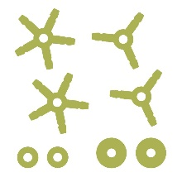
205 | Suitcase - round | miscellaneous | Youth Services Office | 7 3/4”W x 8 3/8”H | 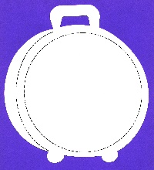
95 | Sun #2 2 pcs (starburst) | space | Youth Services Office | 4 1/8"
368 | Sun #8 | space | Creation Studio | 4 1/8"
113 | Superhero Emblem | miscellaneous | Youth Services Office | 4 1/4"W x 4"H | 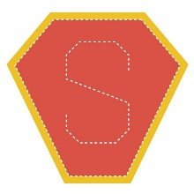
90 | Tag holder #2 | cards/envelopes | Youth Services Office | 1 7/8” W x 3 3/4”H assembled | 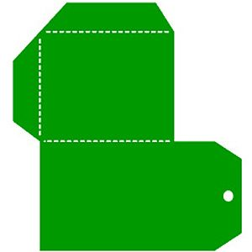
220 | Take-out box | miscellaneous | Youth Services Office | 2 1/16"W x 2 3/16"L x 2 3/16"H (Assembled) | 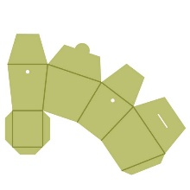
218 | Teddy Bear | miscellaneous | Youth Services Office | 7 3/4"W x 7 15/16"H | 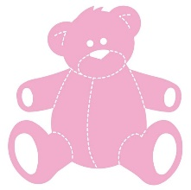
364 | Teddy Bear #1 | miscellaneous | Creation Studio | 3 11/16"W x 4 3/4"H | 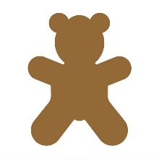
355 | Teddy Bear #11 | miscellaneous | Creation Studio | 3 13/16"W x 4 15/16"H | 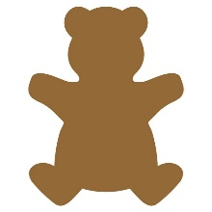
41 | Tent #1 | miscellaneous | Youth Services Office | 5 5/1"W x 3"H | 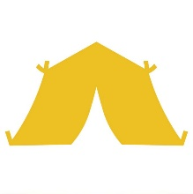
351 | Tent #1 | miscellaneous | Creation Studio | 5 5/1"W x 3"H
71 | Tractor #1 | farm | Youth Services Office | 5 1/8"W x 4"H
305 | Trapezoid | shape | Creation Studio | 5"W x 2 3/16"H (Sides 2 1/2")
34 | Treasure Chest | miscellaneous | Youth Services Office | 4 1/2” W x 4 3/8” H | 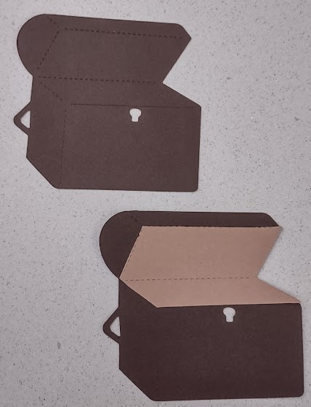
20 | Tree #2 | plants | Youth Services Office | 3 1/4"W x 5 1/16"H
344 | Tree #3 | plants | Creation Studio | 4 1/16"W x 4 1/2"H
345 | Tree #5 | plants | Creation Studio | 4 1/4"W x 4 3/4"H | 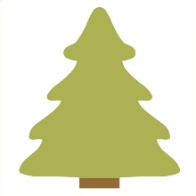
316 | T-Rex | animals | Creation Studio | 5 15/16"W x 2 11/16"H | 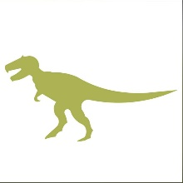
7 | Triangle | shape | Youth Services Office | 4"x4"x4"
306 | Triangle | shape | Creation Studio | 4 3/4"W x 4 1/8"H
318 | Triceratops | animals | Creation Studio | 4 11/16"W x 2 3/16"H | 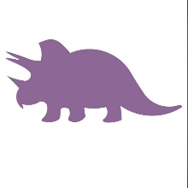
35 | Trophy | sports | Youth Services Office | 2 5/8"W x 4 3/4"H
126 | Truck-Pickup | vehicle | Youth Services Office | 5"W x 1 5/8"H
127 | T-shirt #2 | clothing | Youth Services Office | 5"W x 4 1/8"H | 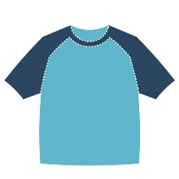
369 | Turkey #2 | bird | Creation Studio | 4 1/4"W x 4 3/4"H | 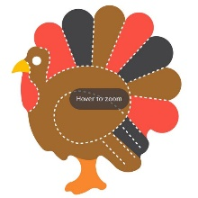
331 | Turkey #3 | bird | Creation Studio | 4 3/16"W x 4 13/16"H | 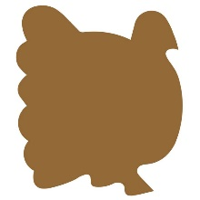
349 | Umbrella #2 | clothing | Creation Studio | 4 1/4"W x 5"H
121 | Unicorn | miscellaneous | Youth Services Office | 4 1/4"W x 4 1/4"H
321 | Velociraptor | animals | Creation Studio | 5"W x 3"H | 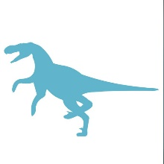
82 | Whale #3 | underwater | Youth Services Office | 5 3/16"W x 2 9/16"H
101 | Word - Thanks | miscellaneous | Youth Services Office | 5 5/16"W x 2 3/8"H
231 | XL Action figure Snowman (6 attachable pieces to make a snowman) | winter | YS | 7 1/2" W x 10 1/4" H (body 5 1/4"W x 5 1/4"H; head 4" W x 3 3/4" H; mittens 1 1/2" W x 2 3/4"H; boots 3"W x 2"H) | 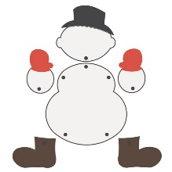
232 | XL Reindeer hat | clothing | YS | 7 1/2" W x 7" H (head), 1 1/2" circle (nose); requires #130 hat band to complete | 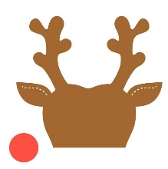
230 | XL Snowman cup hugger | winter | YS | 10 1/2" W x 7 3/4"H | 